**Steghide Awesome Lab Fun Time**

So here is a quick glimpse at a nice program used for steganography. Keep in mind that this is only one program and there are tons out there that do close to the same thing. Keep in mind though that this program only works with \*\*\*\***JPEGS**\*\*\*\*. Anyway let’s get started.

1. First off you will need to download the program you can get it from the link below or you can grab it off of aurora.

* <http://steghide.sourceforge.net/>

1. After you download the file unzip it into the C:\ drive. (Note: You can really put it anywhere but for simplicity sake we are just going to place it here)
   * When you’re done it should look something like this

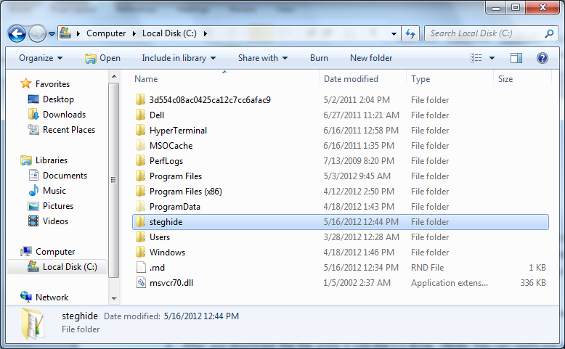

1. Okay I bet that was exciting! Hang in there though it will get better!
2. Before we can start working on this lets go grab a picture that can be used for this lab. (Aka go to google and grab a **JPEG**) Here’s the jpeg I’m using for your viewing pleasure.
   * **Make sure you save this photo into the steghide folder located here C:\**
   * (Note: you don’t have to save it here but again so you don’t have to specify path names later on just do what I say and save it where I tell you, it’s less painful that way.)

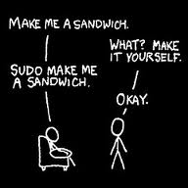

1. Okay! Almost ready to start all that’s left is to create a quick txt file! So go ahead and open Notepad and type up a short sentence.

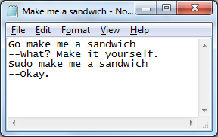

* + **SAVE THIS IN THE STEGHIDE FOLDER!!!! YOU KNOW WHERE IT IS!!!!**

1. Okay before we really jump into things lets pay attention to one little thing, the size of the file beforehand and then afterward. Since I’ve already done this I’ll just paste in what I’ve found out. So yes using this program ups the size of the file!

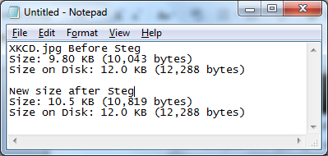

1. Alright the preparations are all set so go ahead and open a cmd and move to the steghide folder.

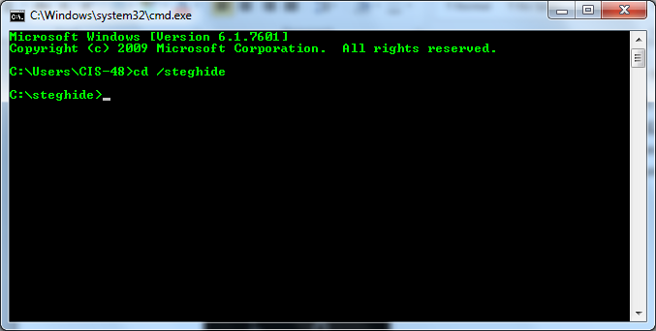

1. Now let’s learn a bit more about steghide so go ahead and type the command
   * steghide --help

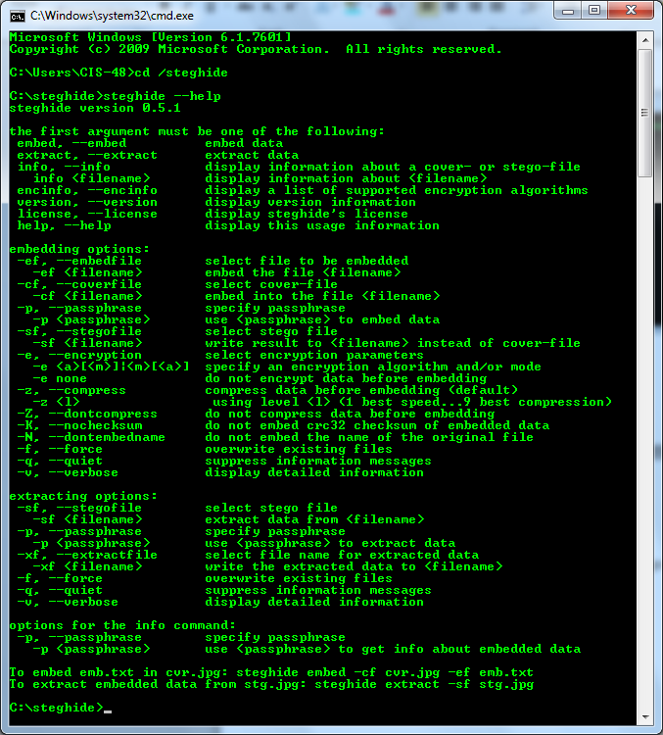

1. Oh my that’s a lot of options; fortunately we only have to pay attention to the very last two lines of this help feature!
   * **Embed command:** steghide embed –cf (example).jpg –ef (example).txt
   * **Extract command:** steghide extract –sf (example).jpg
2. So let’s go ahead and use that embed command.

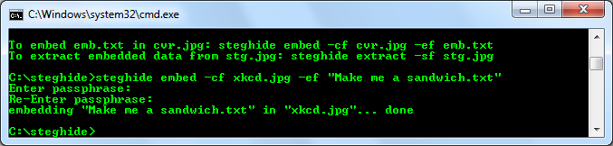

* Notice after you enter the command it asks you to enter a passphrase. This makes sure that even if a person is able to tell that you have used this program it does them no good unless they have the passphrase (insert evil laugh here). For simplicity sake skip entering a passphrase just by hitting enter twice.

1. So the program ran but how do we know that it worked? Well we can figure that out by using another command.
   * Type this command in: **steghide –info xkcd.jpg**

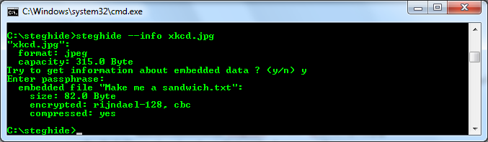

* + Notice it will ask if you want to get info about this particular jpg so hit **y**
  + Next it will ask for the passphrase of the embedded file, if you didn’t type anything in just press **enter**.
  + After that it shows you the embedded file that is in this specific jpeg, how it was encrypted and the size of the embedded file.
  + **Note: if you look at capacity: 315.0 Byte; this is telling you how much data can be hidden within this specific jpeg.**

1. Now go ahead and go to your steghide folder using windows explorer and delete your text file that you created. So your folder should look something like this.

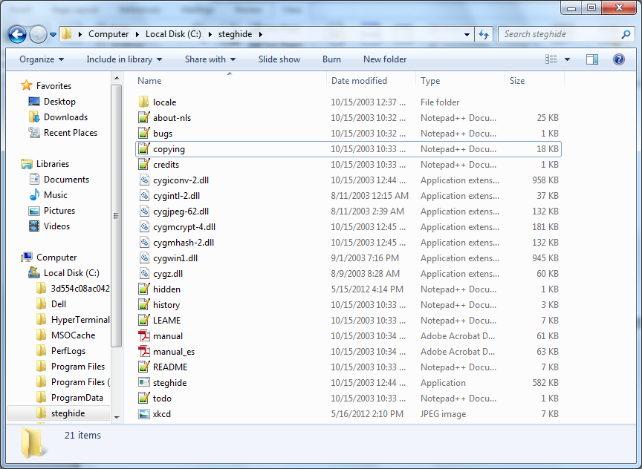

1. Okay now that the text file is gone let’s bring it back. Do not bring it back from the trash bin. Instead let’s extract it from our steg’d jpeg.
   * **Use this command: steghide extract –sf xkcd.jpg**

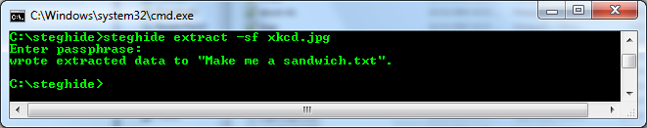

1. If everything worked properly it should be back in your steghide folder!

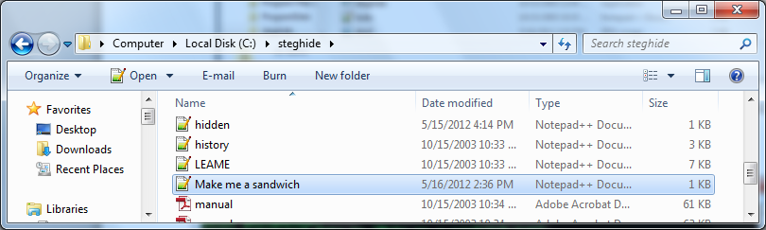

Congrats! You’ve finished the lab! Be sure to submit a lab report of what you’ve found. You can use the standard lab report that we have provided in the past as a template if you would like.